Name: مصطفى عبد الحكيم احمد عبدالسلام

B. N: 925

Group :7

TOPIC: Artificial Intelligence

1 -Artificial Intelligence

magine a future in which intelligence is not restricted to humans!!! A future where machines can think as well as humans and work with them to create an even more exciting universe. While this future is still far away, Artificial Intelligence has still made a lot of advancement in these times. There is a lot of research being conducted in almost all fields of AI like **Quantum Computing, Healthcare, Autonomous Vehicles,**[Internet of Things](https://www.geeksforgeeks.org/introduction-to-internet-of-things-iot-set-1/)**, Robotics**, etc. So much so that there is an [increase of 90%](https://www.forbes.com/sites/louiscolumbus/2018/01/12/10-charts-that-will-change-your-perspective-on-artificial-intelligences-growth/#7833c3347583) in the number of annually published research papers on Artificial Intelligence since 1996.  
Keeping this in mind, if you want to research and write a thesis based on Artificial Intelligence, there are many sub-topics that you can focus on. Some of these topics along with a brief introduction are provided in this article. We have also mentioned some published research papers related to each of these topics so that you can better understand the research process.

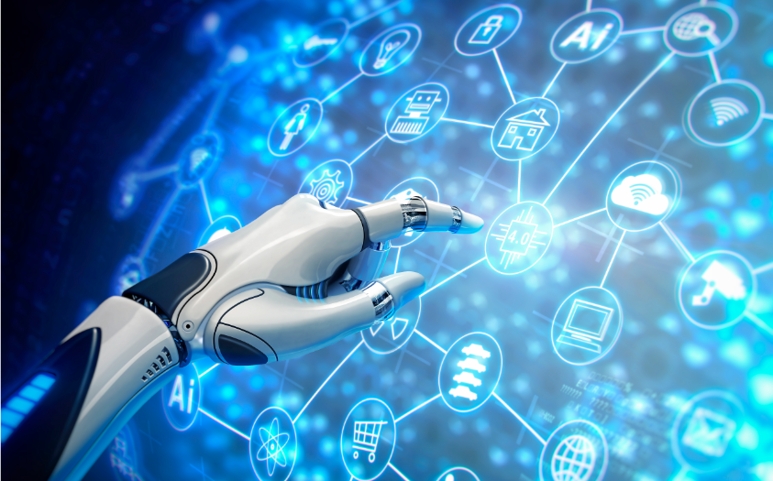

## 2-**How does AI work?**

AI works through algorithms that act from programming rules and its subset **Machine Learning (ML)** and the different ML techniques such as **Deep Learning (DL).**

**1. Machine Learning**

[Machine Learning](https://www.geeksforgeeks.org/machine-learning/)involves the use of Artificial Intelligence to enable machines to learn a task from experience without programming them specifically about that task. (In short, Machines learn automatically without human hand holding!!! This process starts with feeding them good quality data and then training the machines by building various machine learning models using the data and different algorithms. The choice of algorithms depends on what type of data do we have and what kind of task we are trying to automate.  
However, generally speaking, Machine Learning Algorithms are divided into 3 types i.e. **Supervised Machine Learning Algorithms, Unsupervised Machine Learning Algorithms**, and **Reinforcement Machine Learning Algorithms.**

**2. Deep Learning**

[Deep Learning](https://www.geeksforgeeks.org/introduction-deep-learning/) is a subset of Machine Learning that learns by imitating the inner working of the human brain in order to process data and implement decisions based on that data. Basically, Deep Learning uses **artificial neural networks** to implement machine learning. These neural networks are connected in a web-like structure like the networks in the human brain (Basically a simplified version of our brain!).  
This web-like structure of artificial neural networks means that they are able to process data in a nonlinear approach which is a significant advantage over traditional algorithms that can only process data in a linear approach. An example of a deep neural network is [RankBrain](https://en.wikipedia.org/wiki/RankBrain) which is one of the factors in the Google Search algorithm

**3. Reinforcement Learning**

[Reinforcement Learning](https://www.geeksforgeeks.org/what-is-reinforcement-learning/) is a part of Artificial Intelligence in which the machine learns something in a way that is similar to how humans learn. As an example, assume that the machine is a student. Here the hypothetical student learns from its own mistakes over time (like we had to!!). So the Reinforcement Machine Learning Algorithms learn optimal actions through **trial and error.**  
This means that the algorithm decides the next action by learning behaviors that are based on its current state and that will maximize the reward in the future. And like humans, this works for machines as well! For example, Google’s [AlphaGo](https://techcrunch.com/2017/05/24/alphago-beats-planets-best-human-go-player-ke-jie/) computer program was able to beat the world champion in the game of Go (that’s a human!) in 2017 using Reinforcement Learning.

**4. Robotics**

[Robotics](https://www.geeksforgeeks.org/robotics-introduction/) is a field that deals with creating humanoid machines that can behave like humans and perform some actions like human beings. Now, robots can act like humans in certain situations but can they think like humans as well? This is where artificial intelligence comes in! AI allows robots to act intelligently in certain situations. These robots may be able to solve problems in a limited sphere or even learn in controlled environments.  
An example of this is [**Kismet**](http://www.ai.mit.edu/projects/sociable/baby-bits.html), which is a social interaction robot developed at M.I.T’s Artificial Intelligence Lab. It recognizes the human body language and also our voice and interacts with humans accordingly. Another example is [**Robonaut**](https://www.nasa.gov/audience/forstudents/5-8/features/nasa-knows/what-is-robonaut-58.html), which was developed by NASA to work alongside the astronauts in space.

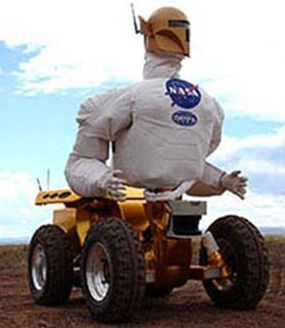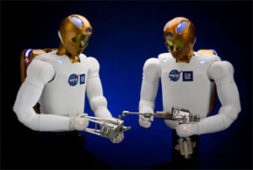

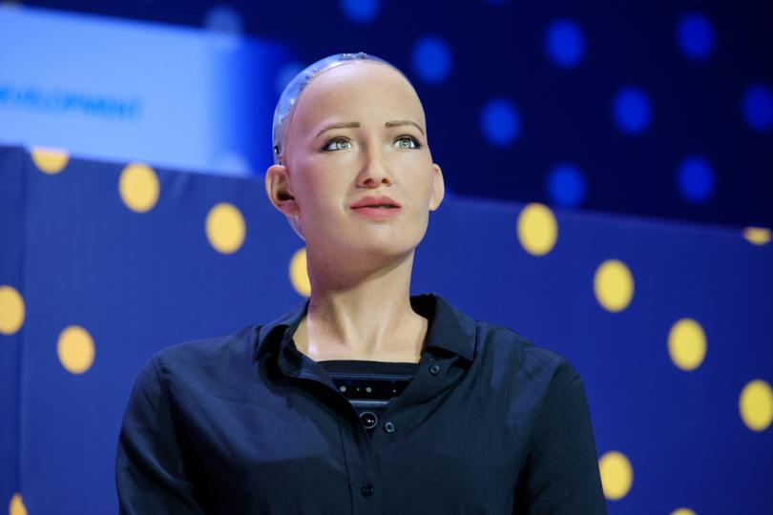

**5. Natural Language Processing**

It’s obvious that humans can converse with each other using speech but now machines can too! This is known as [Natural Language Processing](https://www.geeksforgeeks.org/introduction-to-natural-language-processing/) where machines analyze and understand language and speech as it is spoken (Now if you talk to a machine it may just talk back!). There are many subparts of NLP that deal with language such as **speech recognition, natural language generation, natural language translation**, etc.  
NLP is currently extremely popular for customer support applications, particularly the **chatbot**. These chatbots use ML and NLP to interact with the users in textual form and solve their queries. So you get the human touch in your customer support interactions without ever directly interacting with a human.

Some Research Papers published in the field of Natural Language Processing are provided here. You can study them to get more ideas about research and thesis on this topic.

**6. Computer Vision**

The internet is full of images! This is the selfie age, where taking an image and sharing it has never been easier. In fact, millions of images are uploaded and viewed every day on the internet. To make the most use of this huge amount of images online, it’s important that computers can see and understand images. And while humans can do this easily without a thought, it’s not so easy for computers! This is where [Computer Vision](https://en.wikipedia.org/wiki/Computer_vision) comes in.  
Computer Vision uses **Artificial Intelligence** to extract information from images. This information can be object detection in the image, identification of image content to group various images together, etc. An application of computer vision is navigation for autonomous vehicles by analyzing images of surroundings such as [AutoNav](https://scienceandtechnology.jpl.nasa.gov/research/research-topics-list/communications-computing-software/deep-space-navigation) used in the Spirit and Opportunity rovers which landed on Mars.

Screenshots:

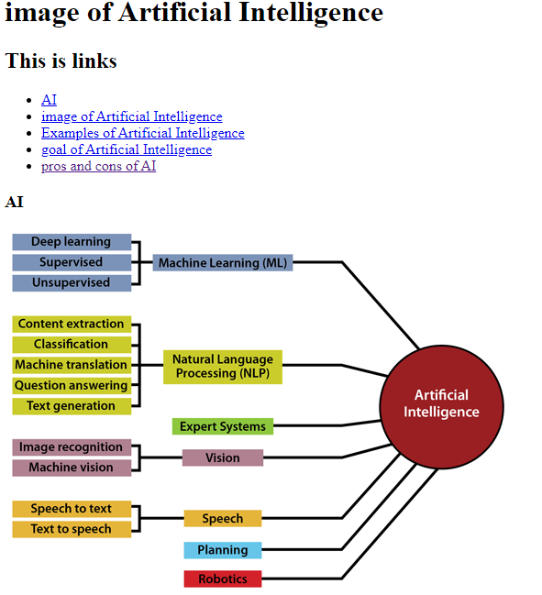

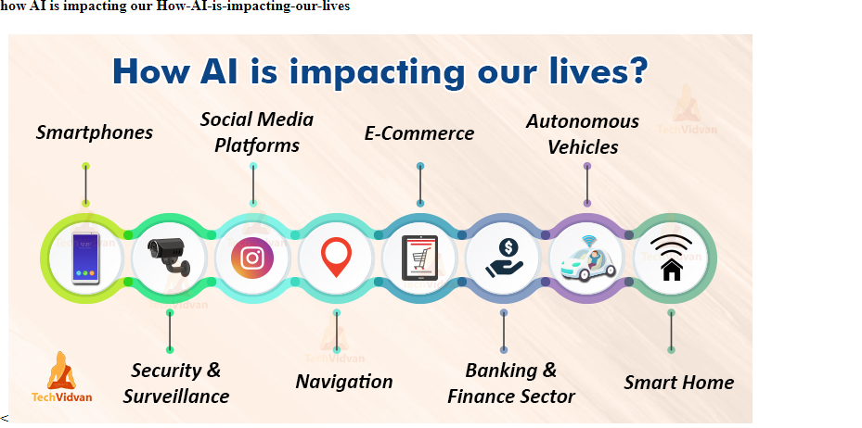

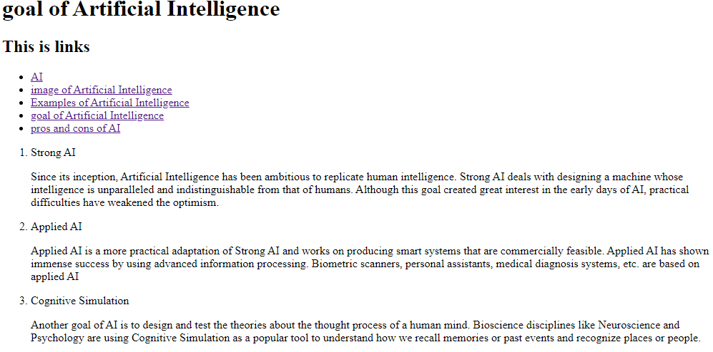

Source code

